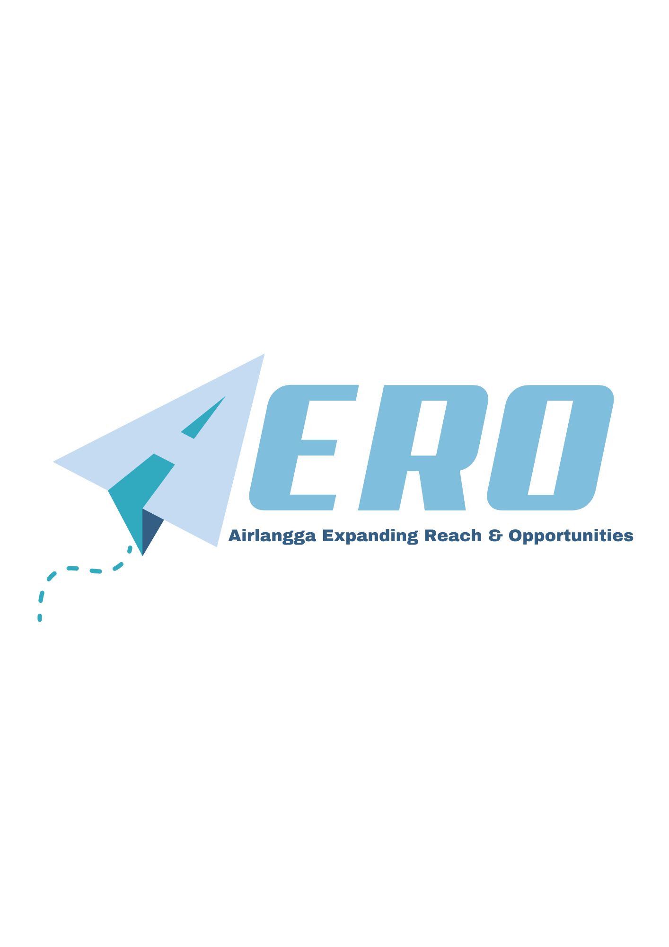

https://global.unair.ac.id/aero-airlangga-expanding-reach-opportunities/

AERO
Airlangga Expanding Reach & Opportunities

AERO is an internationalization event that opens doors for Universitas Airlangga students to explore global opportunities in education, careers, and cultural exchange. More than just an event, AERO reflects UNAIR HEBAT values, shaping students into future-ready individuals with strong character, global insight, and a competitive edge.

Through AERO, students can engage directly with international universities, alumni, and professionals, gaining valuable knowledge and networks to prepare them for the global stage. This event embodies the spirit of HEBAT in the following ways:
- Humble-Honestly – AERO encourages students to seek knowledge with an open mind while staying true to ethical values in academic and professional pursuits.
- Excellent – Students will gain insights into prestigious global education pathways, scholarships, and career-building strategies to help them excel in their respective fields.
- Brave – AERO inspires students to step out of their comfort zones, explore international opportunities, and make courageous decisions that impact their future.
- Agile – The event offers dynamic networking and interactive sessions that help students quickly adapt to global trends and challenges.
- Transcendent – AERO aligns with UNAIR’s vision of producing globally conscious graduates who uphold integrity and contribute meaningfully to society.
What to Expect at AERO?
Partner University Booths | Meet representatives from international partner universities and learn more about study programs, scholarships, and academic opportunities.
Global Talks & Alumni Sharing | Gain firsthand insights from alumni who have studied abroad, learning about their academic experiences, career prospects, and the challenges and opportunities they encountered.
Cultural Exchange & Performances | Experience the richness of global cultures through artistic performances and interactive activities that showcase traditions from different countries.
Networking & Interactive Sessions | Connect with international experts, alumni, and students from diverse backgrounds in engaging and inspiring sessions.

Join us in expanding horizons and embracing new opportunities with AERO!

Rundown: https://docs.google.com/spreadsheets/d/1xTpw6R6wpFJJ0utf3wer2MshczGfisDhFleO4IZZqUI/edit?usp=sharing

Global Talks: 10 menit duration untuk per university
Booth - yang ada di Surabaya:
- Partner University
- EduUSA
- Corners di Unair
- IFI

Susunan Panitia:

No | Divisi | PIC | Job Desc
1. | Registrasi dan Administrasi | - Firo  - Zadina | - Menyiapkan persuratan terkait peminjaman maupun administrasi lainnya  - Menyiapkan daftar absensi peserta dan panitia  - Menerbitkan Letter of Invitation bagi peserta yang membutuhkan  - Menyiapkan QR untuk registrasi pengunjung (mahasiswa Unair)  - Registrasi peserta (ID Card)  - Bersurat untuk networking dinner mengundang perwakilan Fakultas  - Issuing certificate untuk mahasiswa peserta penjaga booth
2. | Perlengkapan dan Transportasi | - Duriati  - Sahrul | - Melakukan peminjaman ruangan, venue maupun perlengkapan yang dibutuhkan  - Membantu menjaga dan menyiapkan kebutuhan perlengkapan  - Mengatur transportasi dari Hotel - Venue - Hotel  - Menjadi Operator ketika Global Talks, AERO Spotlight dan Networking Dinner
3. | Acara dan Surabaya City Tour | - Dian  - Indra | - Menyiapkan keseluruhan acara dan networking dinner  - Menentukan tujuan Surabaya City Tour  - Berkoordinasi dengan EO  - Melakukan koordinasi panitia secara berkala
4. | Konsumsi dan PIC Bazaar | - Melly  - Nastiti | - Menyiapkan konsumsi bagi peserta dan panitia, baik meal box maupun snack box  - Menghubungi vendor bazaar untuk menawarkan membuka booth  - Membantu mengorganisir bazaar baik sebelum maupun ketika acara berlangsung
5. | Publikasi dan Dokumentasi | - Diffa  - Ehud | - Membantu menyiapkan promotional content pre-acara: promosi di instagram, website maupun email blast, dan poster acara  - Membuat teaser acara  - Membuat backdrop dan desain umbul-umbul  - Mendokumentasikan saat acara sedang berlangsung sebagai live report IG  - Membuat berita ketika acara selesai
6. | PR - Liaison Officer (LO) | - Joshua  - Intern (who?) | - Membantu menjadi advokat acara untuk public, baik bagi partner maupun stakeholder UNAIR  - Membantu dan mendampingi mitra selama berlangsungnya acara  - Mengkoordinir penugasan LO dan tim volunteer di masing-masing divisi
7. | Bendahara dan Hotel | - Mas Rocky  - Lusy | - Berkoordinasi dengan hotel terkait akomodasi peserta  - Mengkoordinir terkait keuangan dan SPJ  - Berkoordinasi dengan vendor EO dan PLP

